**PROJECT TITLE: THE TABLEAU HR SCORECARD: MEASURING SUCCESS IN TALENT MANAGEMENT**

1**. INTRODUCTION**

**1.1 OVERVIEW**

The Human Resource scorecard is well known HR tool. One of the key problem that HR has been facing in the past decades is the perception that HR doesn’t add to the company strategy. It is the Strategic HR measurement system that helps to measure, manage, and improve the strategic role of the HR department.

* 1. **PURPOSE**

An HR Department can help provide organizational structure and the ability to meet business needs by effectively managing the employee life cycle.

* Talent management
* Compensation
* Employee Benefits
* Training
* Compliance
* Workplace safety.

1. **PROBLEM STATEMENT AND DESIGN THINKING**:

Despite the extraordinary contribution of HRM to organizational performance daily, Such as building relationships, conflict management and cultivating an excellent corporate culture and values, organization still face numerous difficulties managing HR capital to achieve organizational success.

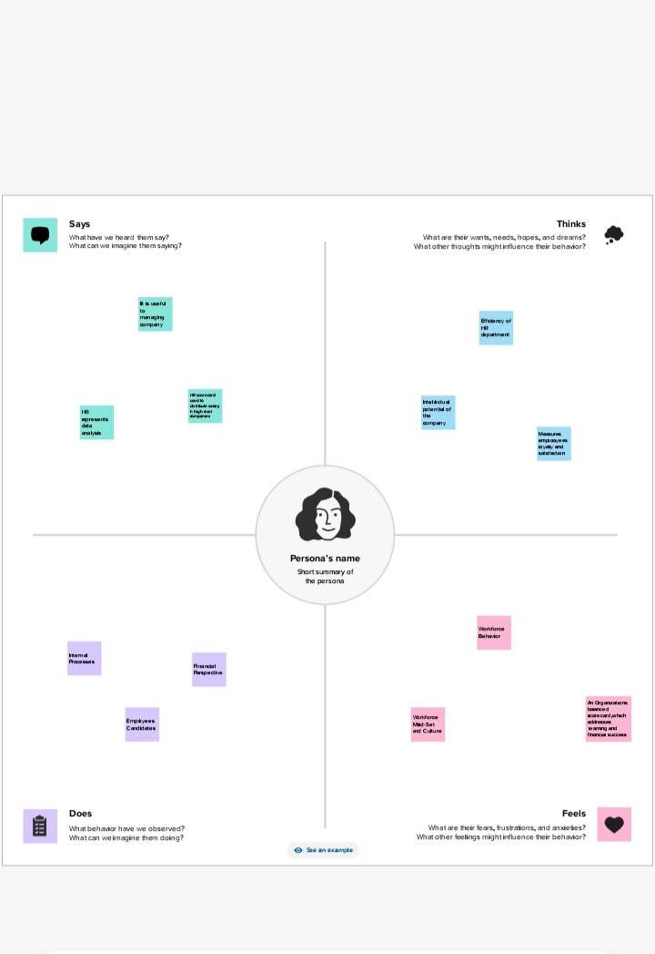

**IDEASIATION AND BRAINSTORMING**

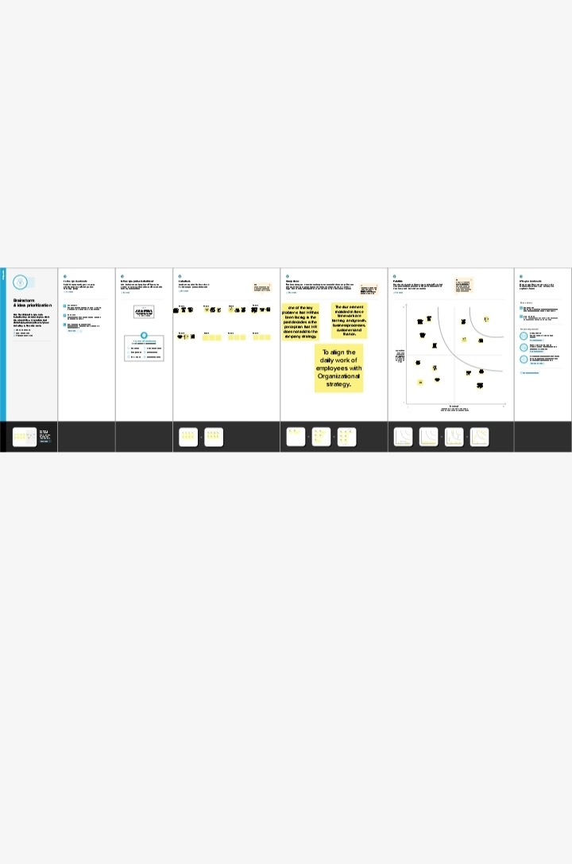

RESULT :

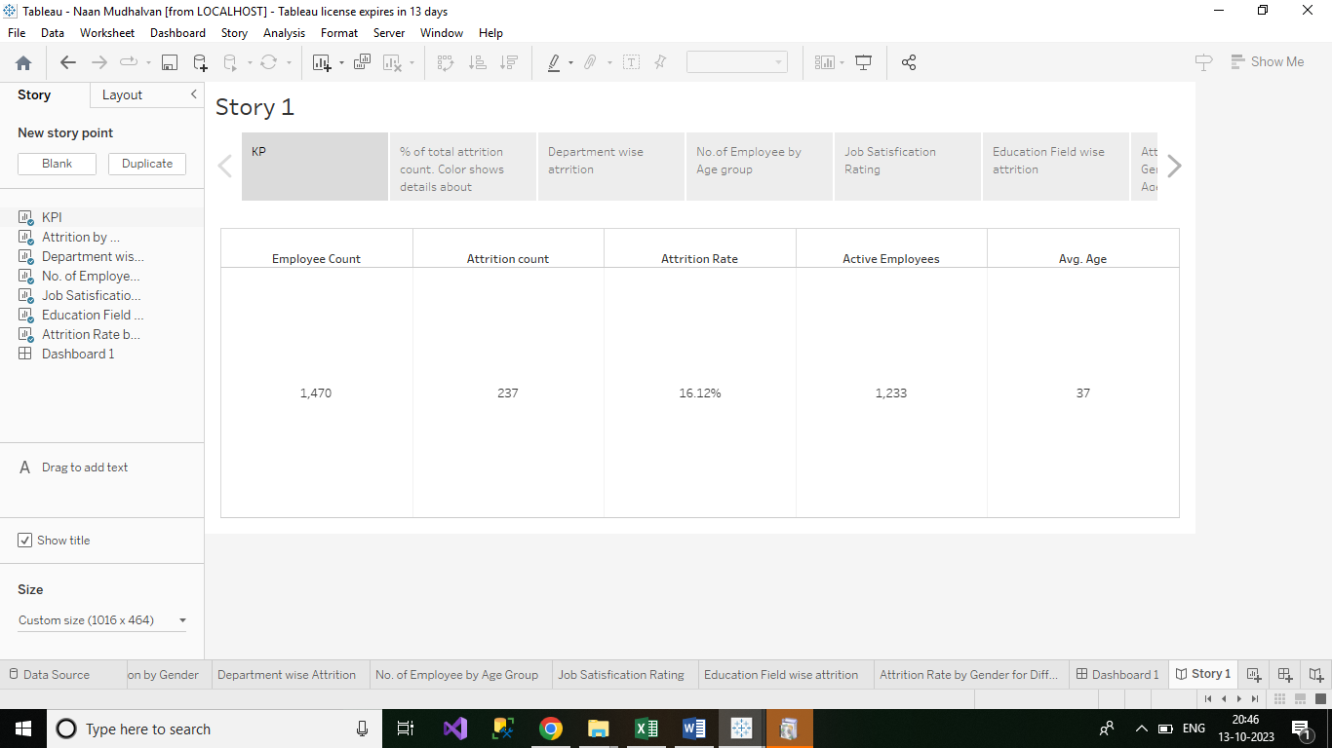

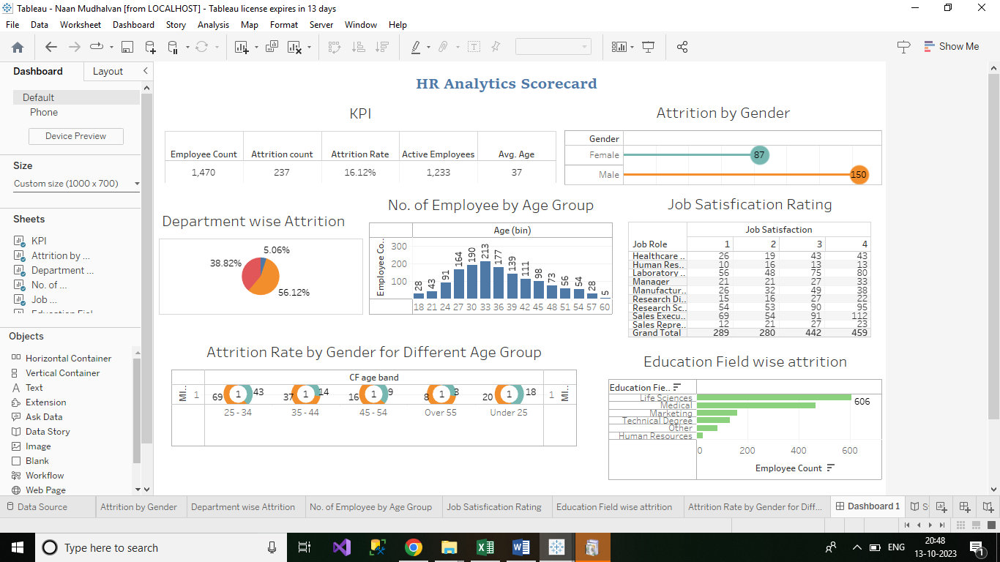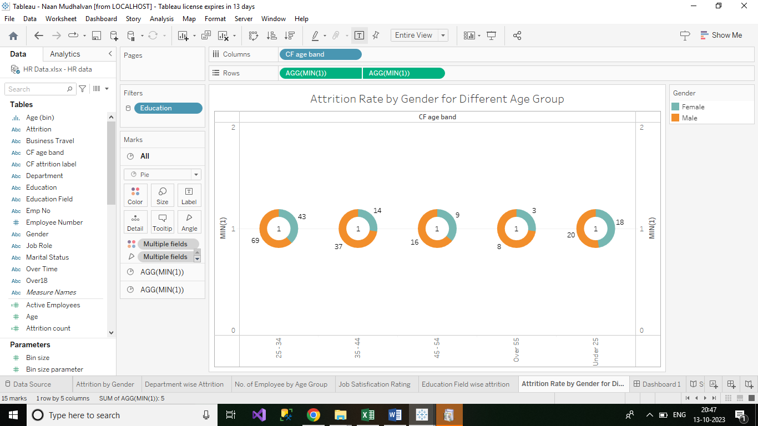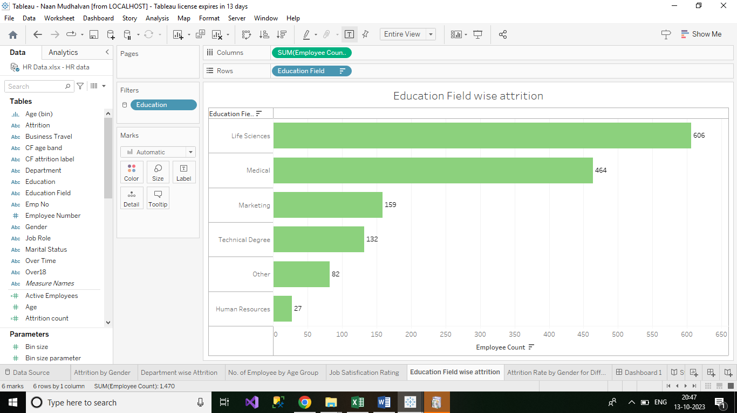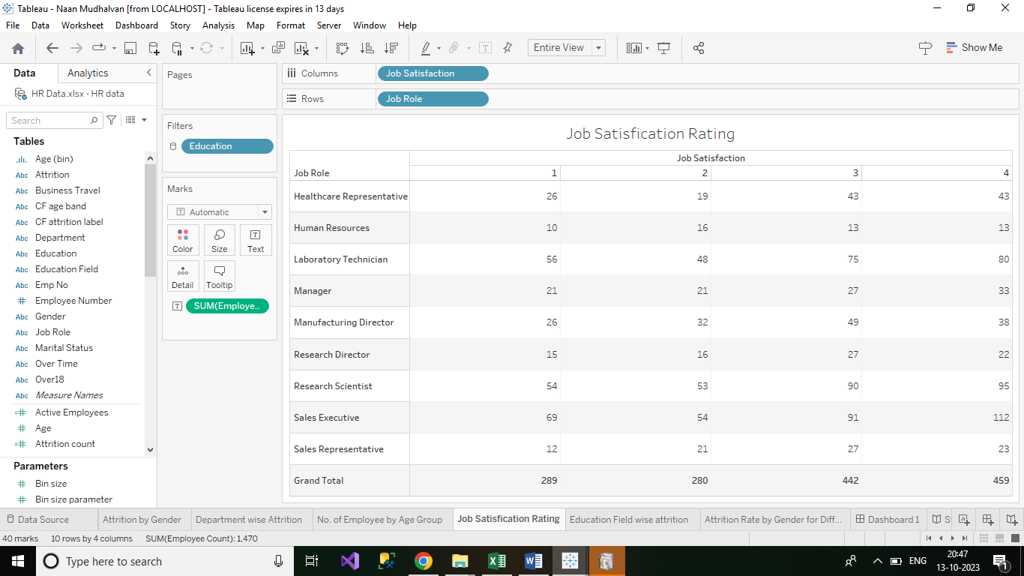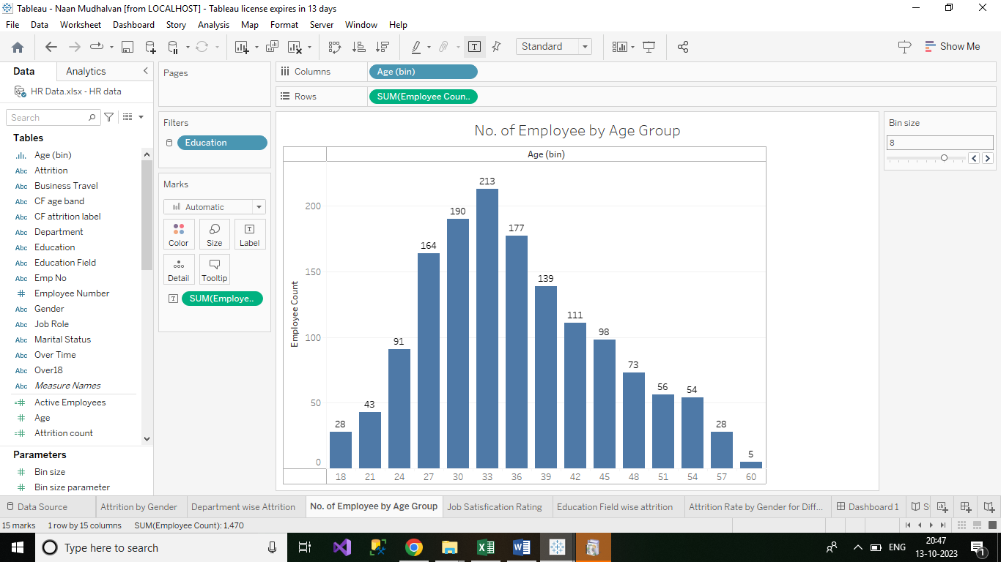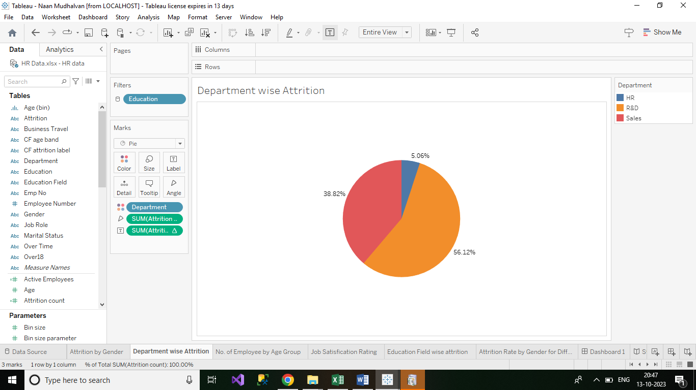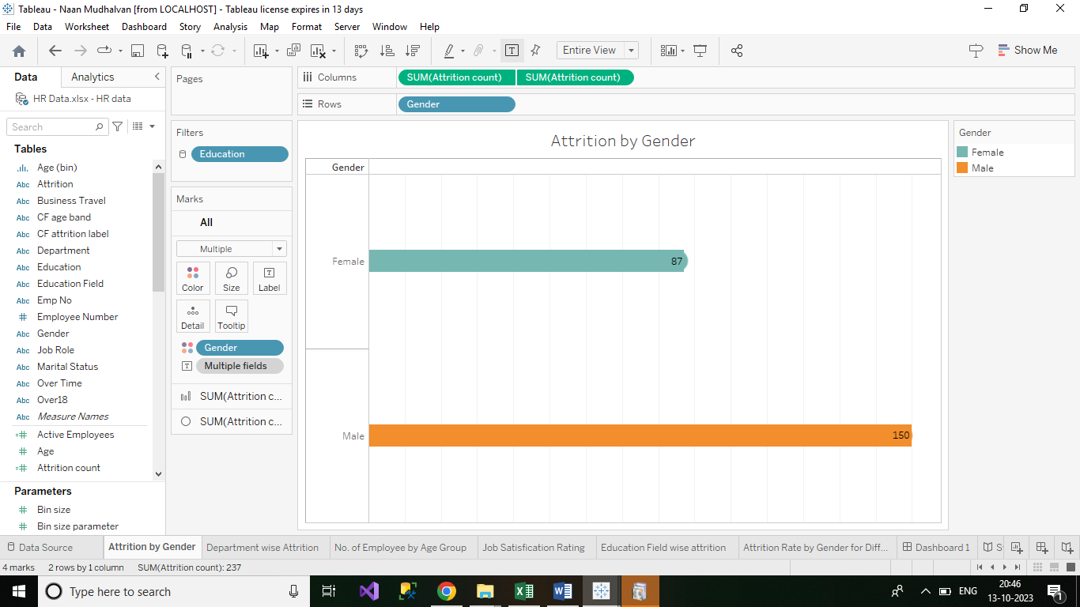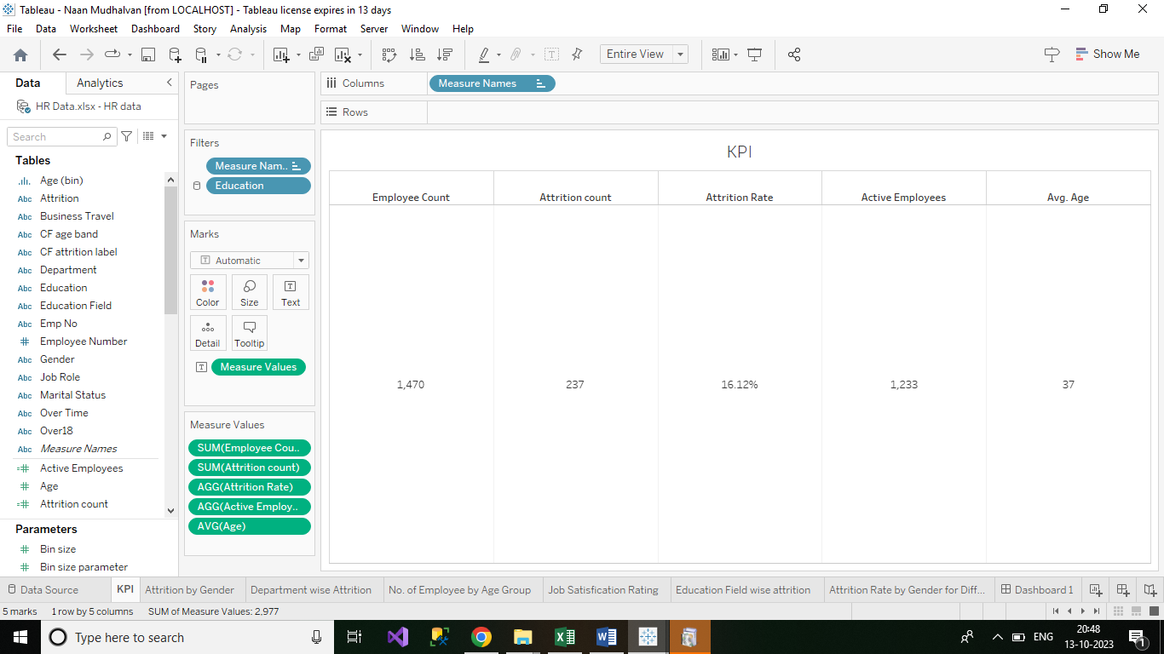

1. **ADVANTAGES AND DISADVANTAGES:**

**ADVANTAGES**

* Give structure to the strategies
* Define your goal and objectives
* Makes it easy a to communicate the strategy.

**DISADVANTAGES**

* A disadvantage of adding a human resources department is that it requires you to relinquish control regarding how your business operates.
* Important decisions in key areas, including hiring and personal relations
* It can get complicated.

**5. APPLICATIONS**:

* The HR scorecard is meant to measure leading HR indicators of business performance .
* Leading indicators are measurement the predict future business growth.

**6. CONCLUSIONS:**

The soft and hard Human resource management influence on the business and lets them development rapidly.

**7. FUTURE SCOPE:**

* An MBA in HR is now in high demand and demand is expected to rise in the future.
* HR specialist are responsible for the recruitment, supervision, and development of employees in an ever-changing labour market.